Orders of Insects

➢ Higher the status of species as pest more important the species is.
➢ Crop losses by the insect pests vary from 10-40 %
❖ Different pesticides used:
Insecticides
60%
Fungicides
19%
Herbicides
16%
Bio pesticides
2%
Others
3%
❖ ORDERS OF INSECTS:
Chilopoda
(Chilo - lip; poda - appendage)
e.g. Centipedes
Diplopoda
(Diplo - two; poda- - appendage)
e.g. Millipede
Crustacea
(Crusta - shell)
e.g. Prawn, crab, wood louse
Arachnida
(Arachne - spider)
e.g. Scorpion, spider, tick, mite
❖ CHARACTERS OF DIFFERENT ORDERS:
Characters
Crustacea
Arachnida
Habit
Aquatic and few terrestrial
Terrestrial
Antenna
2 pair
No antenna
Visual organs
One pair Compound eyes
One pair-simple eyes
Locomotor organs
Minimum five pairs of legs Four pairs
Respiration
Gill breathing
Book lungs (Scorpion) and
tracheal(spiders)
Body fluid
Hemolymph
Hemolymph
Circulatory system
Heart with ostia
Heart with ostia
Characters
Chilopoda
Diplopoda
Hexapoda
Habit
Terrestrial
Terrestrial
Many terrestrial
and very few
aquatic
Antenna
One pair
One pair
One pair
Visual organs
One pair-simple eyes
One pair-simple eyes
Both simple eyes
and compound eyes
(one pair)
Locomotor organs
One pair per segment
(First pair of legs
modified as poison
claws)
Two pair per segment
(No poison claws)
Respiration
Tracheal
Tracheal
Tracheal
Body fluid
Hemolymph
Hemolymph
Hemolymph
Circulatory system
Heart with ostia
Heart with ostia
Heart with ostia
❖ Class Insecta has 2 sub-classes:
1. Apterygota
2. Pterygota
❖ Pterygota is further divided into
➢ Exopterygota
➢ Endopterygota
❖ Apterygota:
➢ Primarily wingless, metamorphosis absent, pregenital appendages present.
➢ It includes the orders:
✓ Protura (telsontails)
✓ Diplura (japygids)
✓ Collembola (springtails)
✓ Thysanura (silverfish)
❖ Exopterygota-
➢ Wings developed externally, metamorphosis incomplete, pupa absent, immature nymphal
stage present.
➢ Incomplete metamorphosis- presence of 3 stages; eggs, nymph and adult.
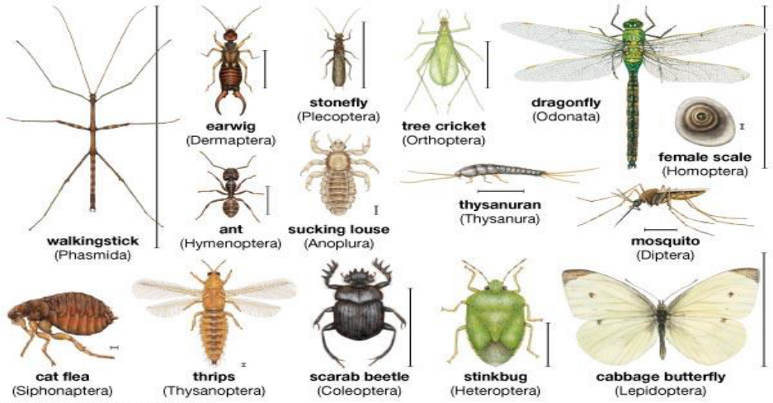

❖ Endopterygota:
➢ Wings developed internally, metamorphosis complete, pupa present, immature stage is
larva.
➢ Complete metamorphosis- presence of 4 stages; egg, larva, pupa and adult.
❖ Orders of Exopterygota with their examples:
Orders
Examples
Orthoptera
Locust, Grasshopper
Isoptera
Termite
Thysanoptera
Thrips
Hemiptera
1. Heteroptera: True Bugs
2.Homoptera: Aphid, Leaf Hopper
❖ Orders of Endopterygota with their examples:
Orders
Examples
Coleoptera
Beetles and Weevils (This order is most
damaging)
Lepidoptera
Butterflies and Moths
Diptera
Flies
Hymenoptera
Honeybee, Saw Flies, Ants, Wasps
❖ Metamorphosis: A profound change in form one stage to the next in the
life history of an organism.
❖ Types of metamorphosis:
Ametabolous
No metamorphosis
Hemimetabolous
Incomplete metamorphosis
Holometabolous
Complete metamorphosis
➢ Simple Metamorphosis/ Ametamorphosis: Hatches from egg looking just like the adult
grows in size by molting.
➢ Incomplete Metamorphosis/ Hemi-metamorphosis: Hatches from egg and becomes a
nymph. Nymph does not have fully developed wings. Molts to become an adult.
➢ Complete Metamorphosis/ Holo-metamorphosis:
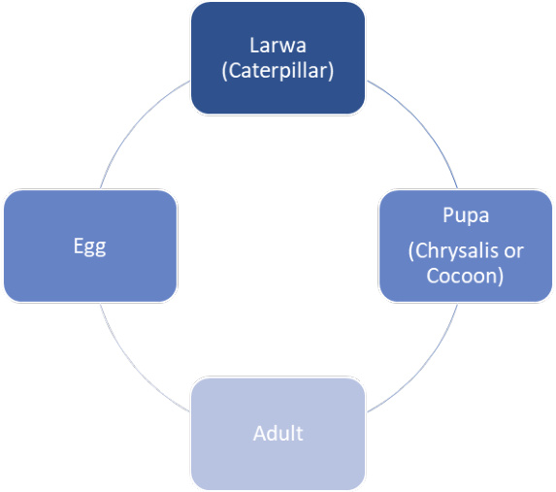

❖ Types of Larvae:
➢ Nymph- Larva of Orthoptera (grasshoppers/locusts) and Hemiptera (bugs, white flies,
aphids and jassids).
➢ Caterpillar- Larva of Lepidoptera (butterflies/moths), Bollworm, borer (except lesser
grain borer.
➢ Grub- Larva of Coleoptera (beetles/ weevils) and Hymenoptera (bees. Wasps, ants).
➢ Maggot- Larva of Diptera (true flies)
➢ Niads- Larva of Odonata (dragonfly/damselfly)
❖ The Insect Head:
➢ The head of an insect is an almost completely sclerotized capsule formed by the fusion of
several sclerites often distinctly seen in the embryo.
❖ Based on the inclination of the long axis and the mouth parts, it is usual to distinguish
three types of heads.
➢ Hypognathous head with the mouth parts ventrally placed the long axis of the head
being vertical. The median line of the head forms right angle with the median line of the
body. Eg. Grasshopper.
➢ Prognathous head- Here the long axis is horizontal, and mouthparts placed anteriorly.
Eg. Beetles.
➢ Opisthognathous head- mouthparts are posterioventral (placed between the anterior pair
of legs) and head directed backwards. E.g., Bugs.
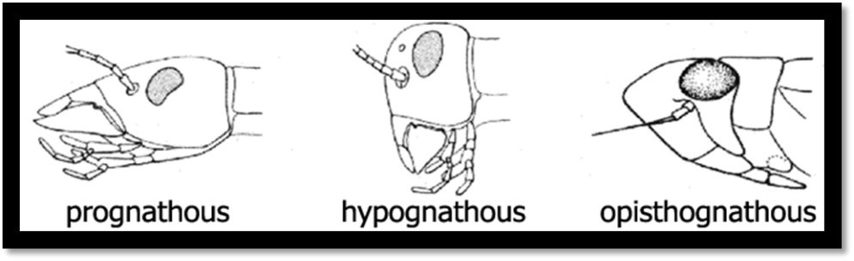

❖ Antennae: Antennae are mobile, segmented, paired appendages. Primitively, they appear to
be eight segmented in nymphs and adults, but often there are numerous subdivisions,
sometimes called antennomeres.

